RECYCLING

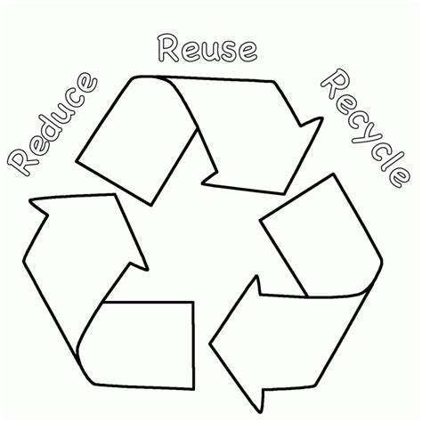
ACTIVITY BOOK

NAME ___________________

Use this number- letter code to find the secret message
1 = A 7 = G 13 = M 19 = S 25 = Y
2 = B 8 = H 14 = N 20 = T 26 = Z
3 = C 9 = I 15 = O 21 = U
4 = D 10 = J 16 = P 22 = V
5 = E 11 = K 17 = Q 23 = W
6 = F 12 = L 18 = R 24 = X

____ ____ ____ ____ ____ ____ ____
18 5 3 25 3 12 5

____ ____ ____ ____ ____ ____ ____
18 5 3 25 3 12 5

____ ____ ____ ____ ____ ____ ____ ____
20 15 4 1 25 6 15 18

____ ____ ____ ____ ____ ____ ____
1 2 5 20 20 5 18

____ ____ ____ ____ ____ ____ ____ ____
20 15 13 15 18 18 15 23

What happens to my rubbish?

Here are the 5 steps for good waste management. The goal is to REDUCE, REUSE and RECYCLE as much as possible

REDUCE WASTE - SHOP WISELY

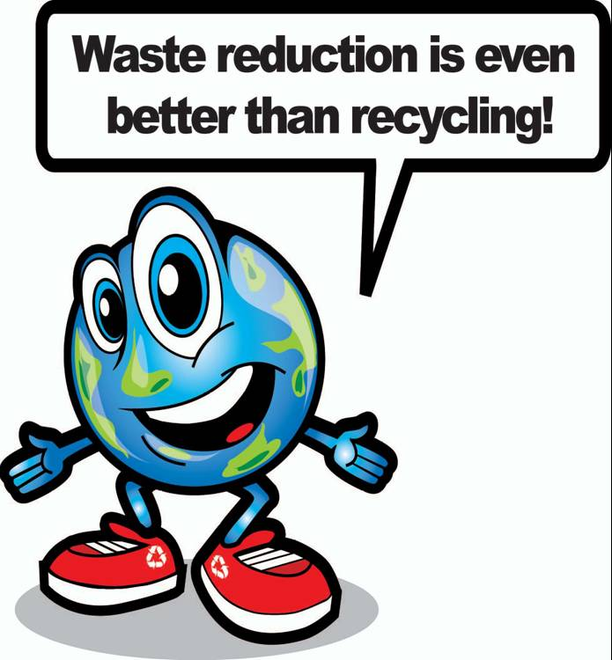
WATAGO FAMILY LIST
- Juice in large bottles
- Rechargeable batteries
- Cereal in large economy boxes
- Reusable plastic plates, cups and bowls
- Fresh fruit & vegetables
- Lunch box
- Thermos flask
- Cloth napkins
- Bars of soap

Write the name of the family with the GROCERY LIST that is better at reducing waste: ____________________

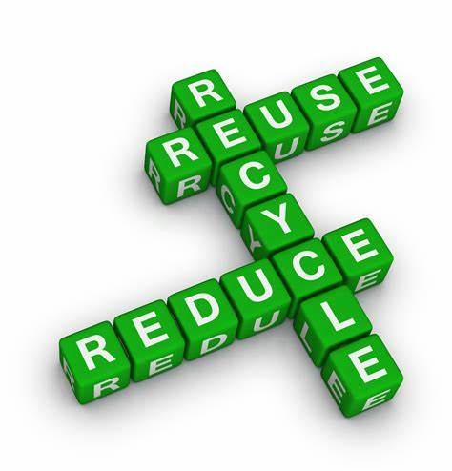
WATTSAMATA FAMILY LIST
- Juice in disposable boxes
- Regular batteries
- Single- serving boxes of cereal
- Paper cups, plates and bowls
- Canned fruits & veggies
- Paper lunch bags
- Six pack of soda
- Paper napkins
- Soap in plastic dispensers

REUSE IT, DON’T BIN IT
Many items around your house can be reused by you or someone else
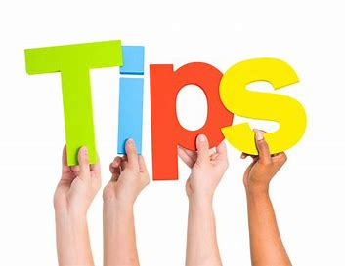

- Donate reusable toys, books and clothes to charity
- Pass on clothes to younger friends or family
- Wrap gifts in reusable gift bags
- Reuse gift bows, gift bags and wrapping paper
- Exchange toys, games and books with friends
- Use washable napkins instead of paper napkins
- Save used items such as buttons, fabric, yarn, beads and coloured paper for craft projects
- Turn old cans or jars into storage containers for school and art supplies
- Write on BOTH sides of the paper
- Refill water bottles instead of buying new bottles
- Have a car boot sale
- Give any unwanted items a new home through Fermanagh Free- cycle

RECYCLE
What bin do I go in?
Circle the items that can be recycled in your BLUE recycling bin.
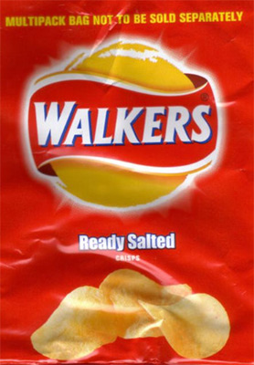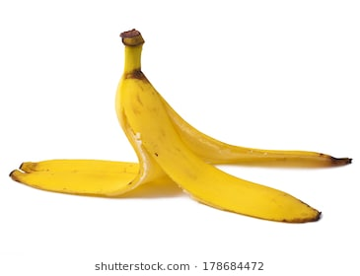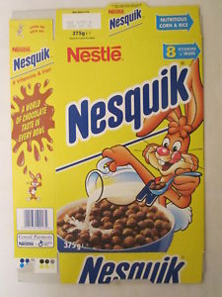

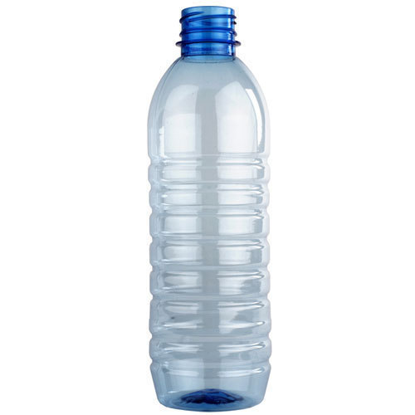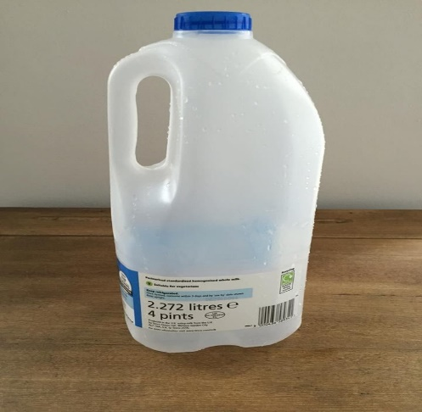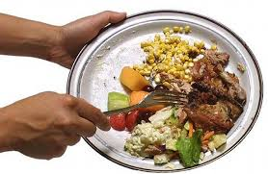
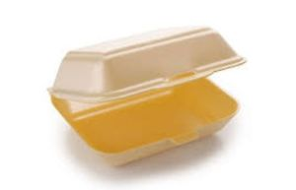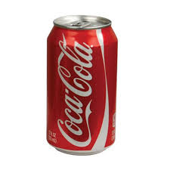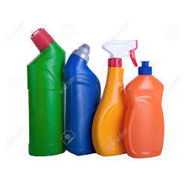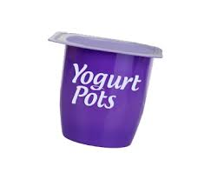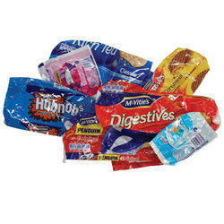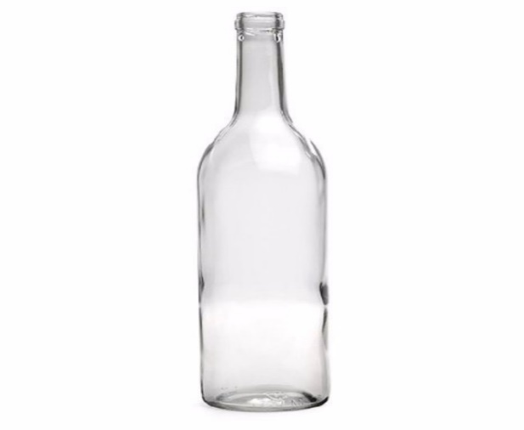

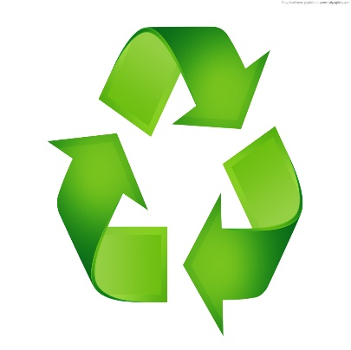
THINGS WE CAN RECYCLE

Organise the words from the word list to fit in the right places of this framework puzzle

8 LETTERS GLASSJARS JUICEBOXES 12 LETTERS
FOODCANS PAPERBAGS GLASSBOTTLES
SODA CANS 11 LETTERS
10 LETTERS MILKCARTONS 14 LETTERS
9 LETTERS NEWSPAPERS CEREAL BOXES PLASTICBOTTLES
CARDBOARD EGGCARTONS
MAGAZINES PHONEBOOKS

CROSSWORD PUZZLE
 |  |  |  |  |  |  |  |  |  |  | 8
 |  |  |  | 3
 |  | 1 |  |  |  | 5 |  | 6
 | 2
 |  |  |  | 4 |  |  |  |  |  | 7
 |  |  |  |  |  |  | 9
 |  |  |  |  |  |  |  | 10
 |  |  |  |  | 11
ACROSS
2. Plastic pots, tubs and trays can be recycled in our ______ bin
4. After you read the ____________ you can reuse it for wrapping paper or recycle it
9. Waste reduction and recycling help to _________ our planet
10. It’s important to _________ plastic, aluminium, newspaper and glass
11. It’s good to donate your old _____ so someone else can play with them

DOWN
1. ________ bottles and jars can be recycled over and over again
3. Lets not litter and keep our district _______
5. All food waste can be recycled in our _______ bin
6. When our black/ green bin is collected, the lorry empties the rubbish at the ______
7. When shopping, use reusable bags instead of _______ bags to reduce waste
8. Use both sides of paper to ______ the amount of paper we use
10. The 3 R’s are Reduce, _______ and Recycle

RECYCLE
What bin do I go in?
Circle the items that can be recycled in your BROWN recycling bin.

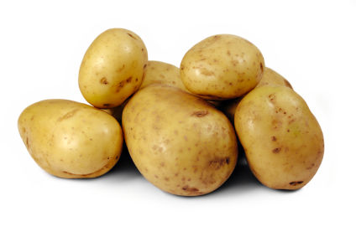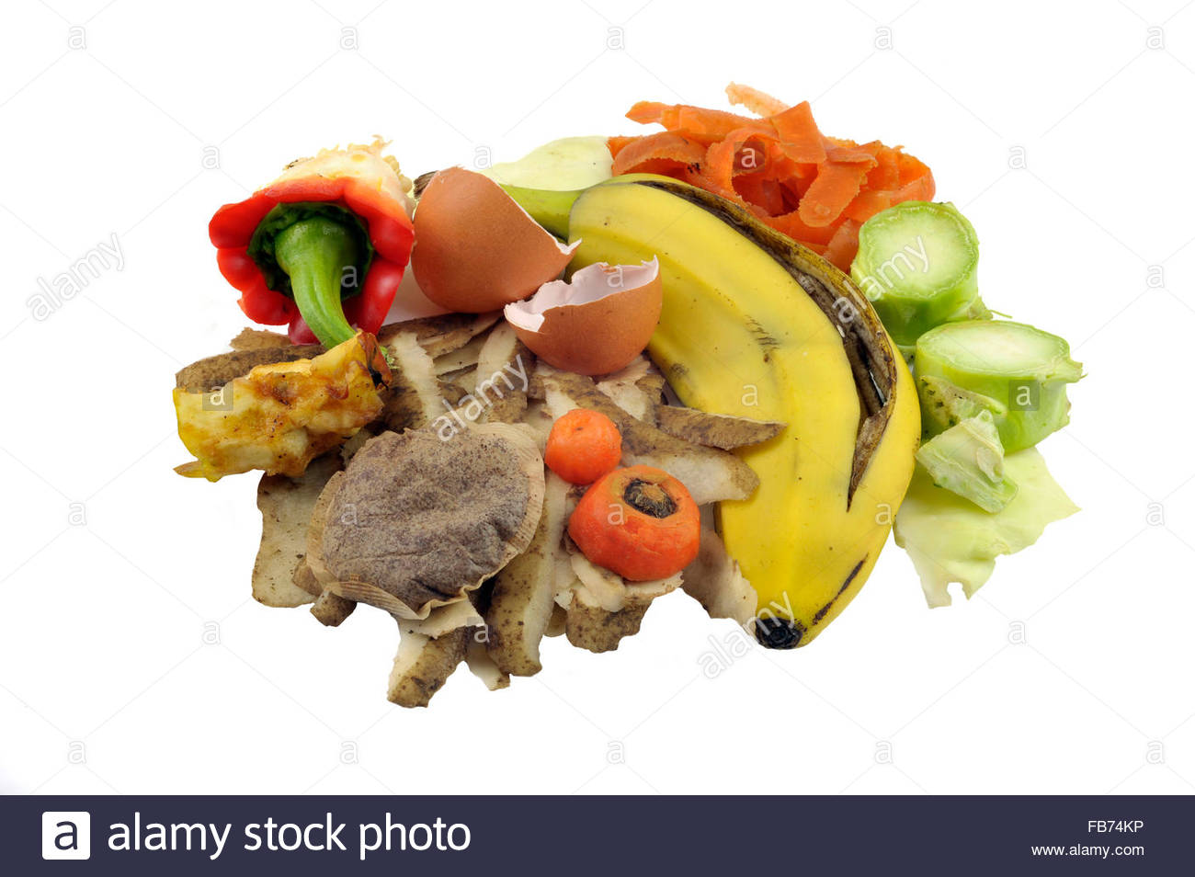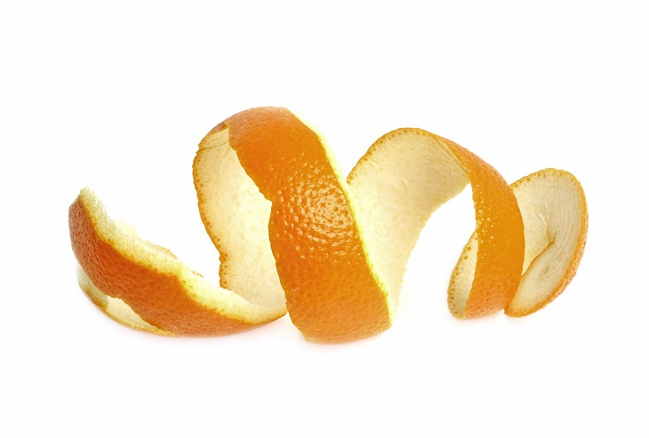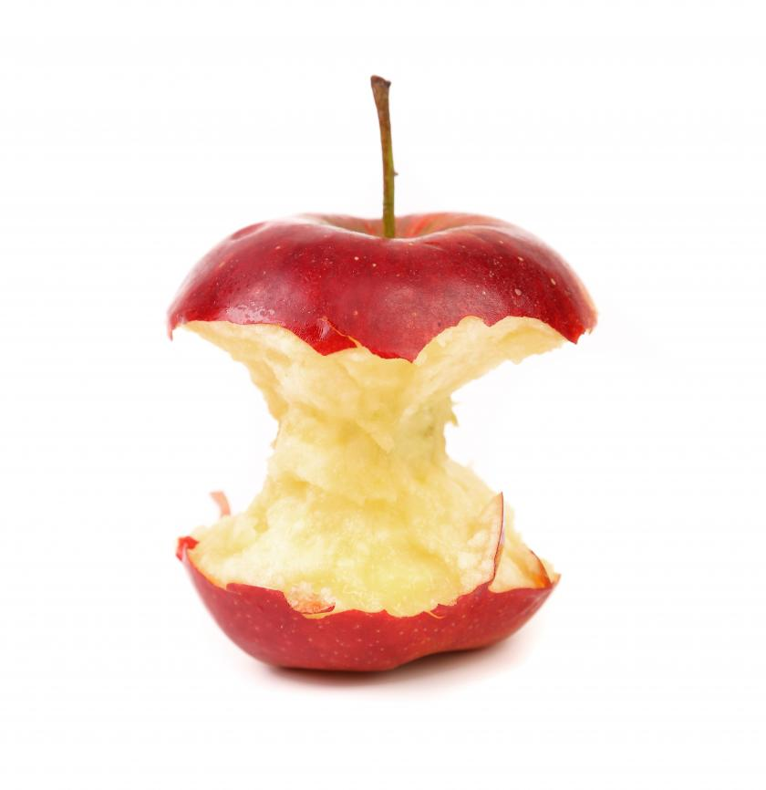

SPOT THE DIFFERENCE
Recycling can be fun for all the family.
Can you spot all 12 differences?
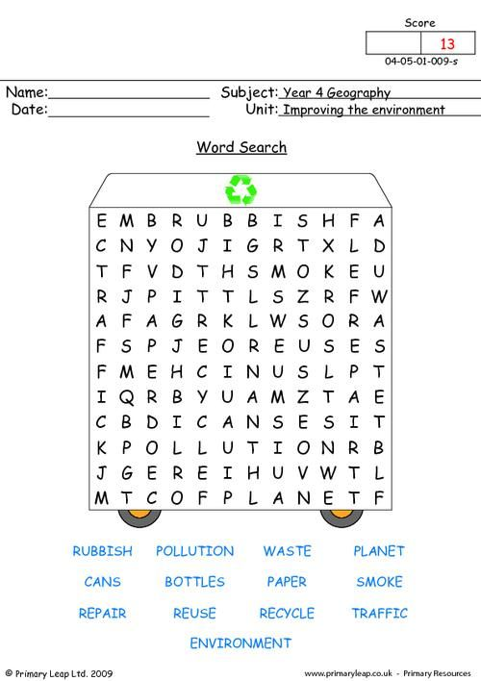
REDUCE

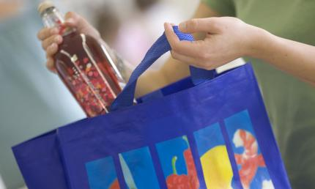
When shopping, use reusable bags instead of plastic bags to reduce waste
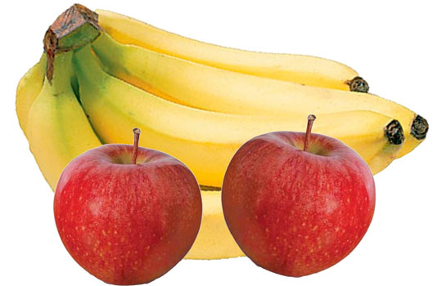
Buy fruit and veg loose when possible

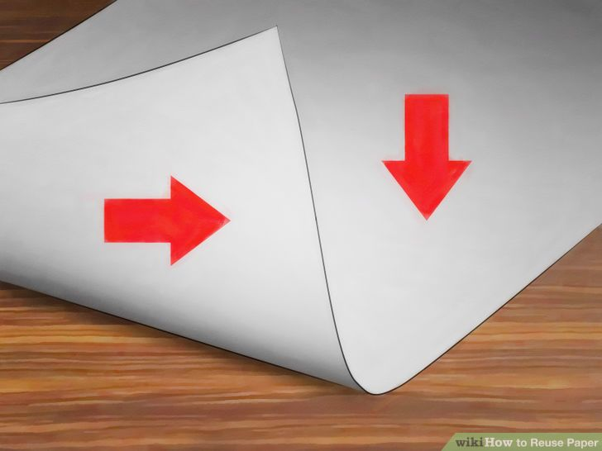

Use both sides of the paper when
drawing
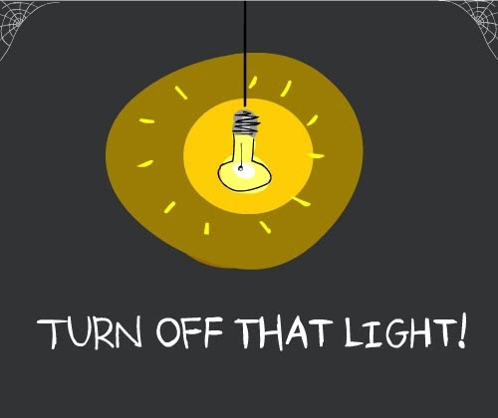

Turn off lights when you are leaving a room – this will save energy
REUSE
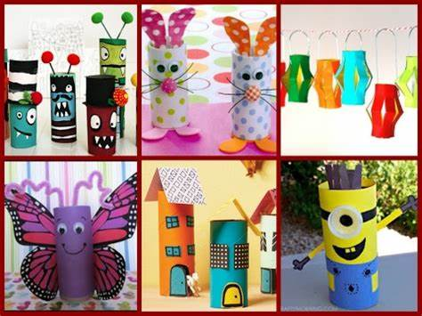
Before recycling your toilet paper roll, why not reuse it to make lots of different arts and crafts
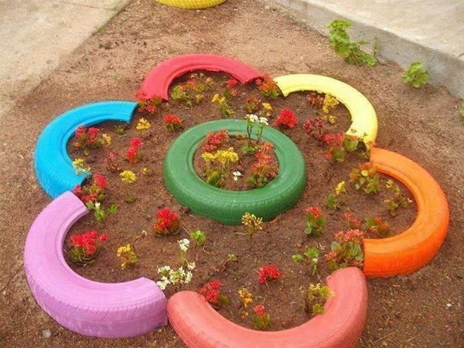
Upcycle old tires into modern and colourful planters.
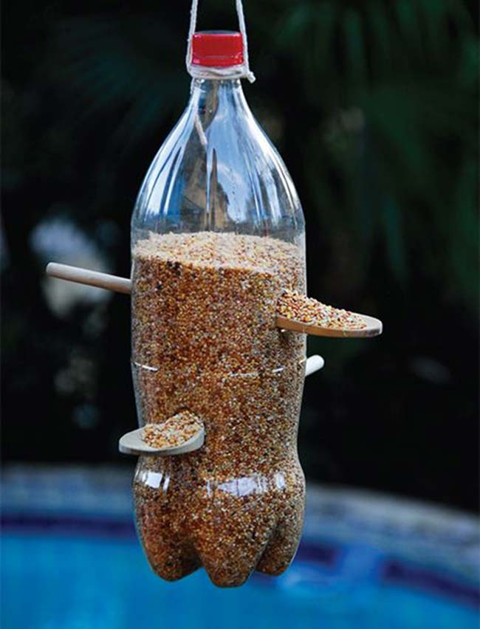
Make a bird feeder from the bottles you would throw away. Just cut a hole in the side large enough to
allow a free flow of seeds, but in such a way that it won’t all fall out on the ground in the
slightest puff of wind, and
won’t get wet if it rains
then hang it out

CROSSWORD PUZZLE
- NEWSPAPER
- PROTECT
- BROWN
- REUSE
- BLUE
- TOYS
- CLEAN
- REDUCE
- DUMP
- RECYCLE
- GLASS
- PLASTIC

 |  |  |  |  |  |  |  |  |  | 8
 |  |  | 3
 | 1 |  |  |  | 5 |  | 6
2
 |  |  | 4 |  |  |  |  |  | 7
 |  |  |  |  |  | 9
 |  |  |  |  |  |  | 10
 |  |  |  | 11

USE THE WORDS AT THE SIDES TO HELP COMPLETE THE CLUES
ACROSS
2. Plastic pots, tubs and trays can be recycled in our ______ bin
4. After you read the ____________ you can reuse it for wrapping paper or recycle it
9. Waste reduction and recycling help to _________ our planet
10. It’s important to _________ plastic, aluminium, newspaper and glass
11. It’s good to donate your old _____ so someone else can play with them

DOWN
1. ________ bottles and jars can be recycled over and over again
3. Lets not litter and keep our district _______
5. All food waste can be recycled in our _______ bin
6. When our black/ green bin is collected, the lorry empties the rubbish at the ______
7. When shopping, use reusable bags instead of _______ bags to reduce waste
8. Use both sides of paper to ______ the amount of paper we use
10. The 3 R’s are Reduce, _______ and Recycle

RECYCLE
Recycling is using old things and making them into new ones. Plastic bottles, papers and drink cans be recycled.
Help Eco find his way through the recycle symbol and put the bottle in the recycle bin.
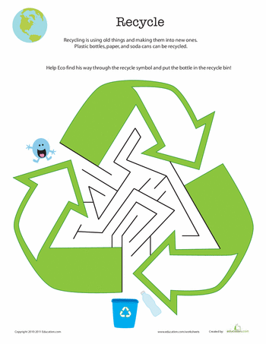
ANSWER PAGE
Secret message – RECYCLE TODAY FOR A BETTER TOMORROW
RECYCLE – WHAT BIN DO I GO IN?

BLUE =

BROWN=

CROSSWORD PUZZLE
 |  |  |  |  |  |  |  |  |  | 8R
 |  |  | 3 C |  |  |  |  |  |  | E
 | 1G |  | L |  | 5B |  | 6D |  |  | D
2 B | L | U | E |  | R |  | U |  |  | U
 | A |  | A |  | O |  | M |  |  | C
 | S |  | 4N | E | W | S | P | A | 7 P | E | R
 | S |  |  |  | N |  |  |  | L
 |  |  |  |  |  |  |  |  | A
 |  |  |  |  |  |  |  |  | S
 |  |  |  |  |  | 9P | R | O | T | E | C | T
 |  |  |  |  |  |  |  |  | I
 |  |  |  |  |  |  | 10R | E | C | Y | C | L | E
 |  |  |  |  |  |  | E
 |  |  |  |  |  |  | U
 |  |  |  | 11T | O | Y | S
 |  |  |  |  |  |  | E

